DAV PUBLIC SCHOOL CWS JAYANT
CLASS 10TH TOPPERS SESSION 2023-24
Students Name | Percentage | Photo
EKANSHI SHRIVASTAVA | 95.2 % | 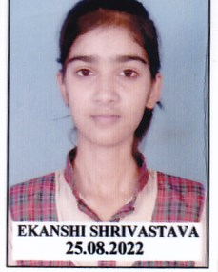
SACHIN KUMAR VISHWAKARMA | 92.8 % | 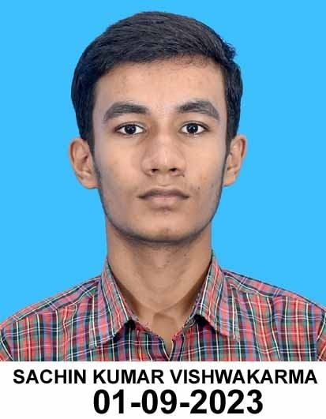
APARNA RANA | 92.2 % | 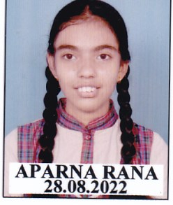
PEEYUSH GUPTA | 91.8 % | 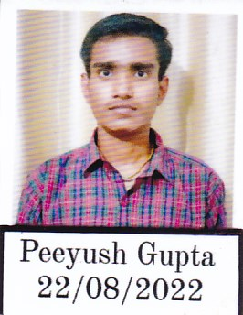
HARSH KUMAR | 90.4 % | 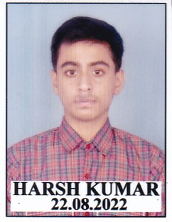

- 100 % Result

